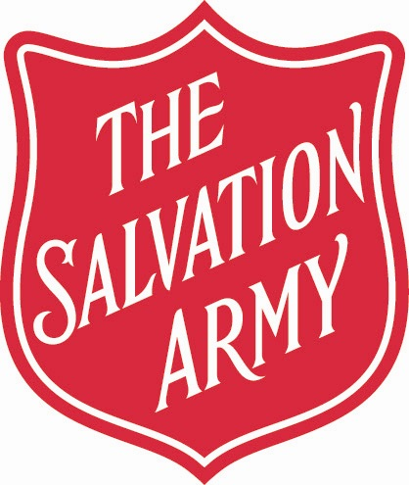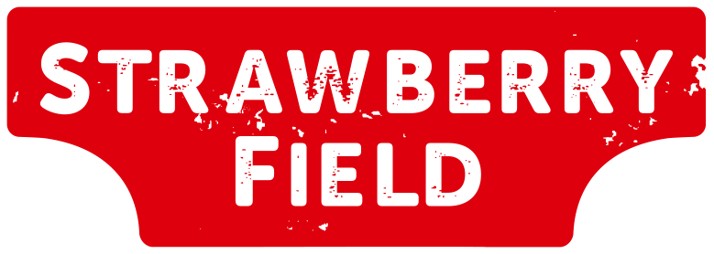

**Photo of a Minor - Consent Form**

Please complete, sign and return this form if you have submitted a photograph to be displayed in the John Lennon Photomosaic of someone aged under 18.

If we do not receive the signed form by [date], we will not be able to include the photograph in the Photomosaic and will instead provide a refund.

Name:

Address:

Contact Number:

Relationship to minor (parent/carer):

Do you have parental responsibility? Yes No

1. I understand that The Salvation Army will use the photograph submitted to be displayed in their visitor experience at Strawberry Field as part of the John Lennon Photomosaic.
2. I confirm that I give permission for the photograph to be used in this way.

Signed:

Date Signed: